**WEEK 5**

**MICROSERVICE HANDSON:**Creating Microservices for account and loan  
  
**CODE:**

**AccountController.java:**package com.cognizant.account;

import org.springframework.beans.factory.annotation.Autowired;

import org.springframework.web.bind.annotation.*;

import org.springframework.web.client.RestTemplate;

import java.util.Map;

*@RestController*

public class AccountController {

*@Autowired*

private RestTemplate restTemplate;

*@GetMapping*("/accounts/{number}")

public Map<String, Object> getAccountByNumber(*@PathVariable* String number) {

// Dummy account data

Map<String, Object> accountData = Map.*of*(

"number", number,

"type", "savings",

"balance", 234343

);

// Call loan service

String loanUrl = "http://localhost:8081/loans/" + number;

Map<String, Object> loanData = restTemplate.getForObject(loanUrl, Map.class);

// Combine account + loan info in one response

return Map.*of*(

"account", accountData,

"loan", loanData

);

}

}

**account/pom.xml:**<?xml version="1.0" encoding="UTF-8"?>

<project xmlns="http://maven.apache.org/POM/4.0.0" xmlns:xsi="http://www.w3.org/2001/XMLSchema-instance"

xsi:schemaLocation="http://maven.apache.org/POM/4.0.0 https://maven.apache.org/xsd/maven-4.0.0.xsd">

<modelVersion>4.0.0</modelVersion>

<parent>

<groupId>org.springframework.boot</groupId>

<artifactId>spring-boot-starter-parent</artifactId>

<version>3.5.3</version>

<relativePath/> <!-- lookup parent from repository -->

</parent>

<groupId>com.cognizant</groupId>

<artifactId>account</artifactId>

<version>0.0.1-SNAPSHOT</version>

<name>account</name>

<description>Account Microservice</description>

<url/>

<licenses>

<license/>

</licenses>

<developers>

<developer/>

</developers>

<scm>

<connection/>

<developerConnection/>

<tag/>

<url/>

</scm>

<properties>

<java.version>17</java.version>

</properties>

<dependencies>

<dependency>

<groupId>org.springframework.boot</groupId>

<artifactId>spring-boot-starter-web</artifactId>

</dependency>

<dependency>

<groupId>org.springframework.boot</groupId>

<artifactId>spring-boot-devtools</artifactId>

<scope>runtime</scope>

<optional>true</optional>

</dependency>

<dependency>

<groupId>org.springframework.boot</groupId>

<artifactId>spring-boot-starter-test</artifactId>

<scope>test</scope>

</dependency>

</dependencies>

<build>

<plugins>

<plugin>

<groupId>org.springframework.boot</groupId>

<artifactId>spring-boot-maven-plugin</artifactId>

</plugin>

</plugins>

</build>

</project>

**AccountApplication.java:**package com.cognizant.account;

import org.springframework.boot.SpringApplication;

import org.springframework.boot.autoconfigure.SpringBootApplication;

import org.springframework.context.annotation.Bean;

import org.springframework.web.client.RestTemplate;

*@SpringBootApplication*

public class AccountApplication {

public static void main(String[] args) {

SpringApplication.*run*(AccountApplication.class, args);

}

*@Bean*

public RestTemplate restTemplate() {

return new RestTemplate();

}

}

**LoanController.java:**package com.cognizant.loan;

import org.springframework.web.bind.annotation.GetMapping;

import org.springframework.web.bind.annotation.PathVariable;

import org.springframework.web.bind.annotation.RestController;

import java.util.Map;

*@RestController*

public class LoanController {

*@GetMapping*("/loans/{number}")

public Map<String, Object> getLoanByNumber(*@PathVariable* String number) {

return Map.*of*(

"number", number,

"type", "car",

"loan", 400000,

"emi", 3258,

"tenure", 18

);

}

}

**loan/pom.xml:**<?xml version="1.0" encoding="UTF-8"?>

<project xmlns="http://maven.apache.org/POM/4.0.0" xmlns:xsi="http://www.w3.org/2001/XMLSchema-instance"

xsi:schemaLocation="http://maven.apache.org/POM/4.0.0 https://maven.apache.org/xsd/maven-4.0.0.xsd">

<modelVersion>4.0.0</modelVersion>

<parent>

<groupId>org.springframework.boot</groupId>

<artifactId>spring-boot-starter-parent</artifactId>

<version>3.5.3</version>

<relativePath/> <!-- lookup parent from repository -->

</parent>

<groupId>com.cognizant</groupId>

<artifactId>loan</artifactId>

<version>0.0.1-SNAPSHOT</version>

<name>loan</name>

<description>Account Microservice</description>

<url/>

<licenses>

<license/>

</licenses>

<developers>

<developer/>

</developers>

<scm>

<connection/>

<developerConnection/>

<tag/>

<url/>

</scm>

<properties>

<java.version>17</java.version>

</properties>

<dependencies>

<dependency>

<groupId>org.springframework.boot</groupId>

<artifactId>spring-boot-starter-web</artifactId>

</dependency>

<dependency>

<groupId>org.springframework.boot</groupId>

<artifactId>spring-boot-devtools</artifactId>

<scope>runtime</scope>

<optional>true</optional>

</dependency>

<dependency>

<groupId>org.springframework.boot</groupId>

<artifactId>spring-boot-starter-test</artifactId>

<scope>test</scope>

</dependency>

</dependencies>

<build>

<plugins>

<plugin>

<groupId>org.springframework.boot</groupId>

<artifactId>spring-boot-maven-plugin</artifactId>

</plugin>

</plugins>

</build>

</project>

**LoanApplication.java:**package com.cognizant.loan;

import org.springframework.boot.SpringApplication;

import org.springframework.boot.autoconfigure.SpringBootApplication;

*@SpringBootApplication*

public class LoanApplication {

public static void main(String[] args) {

SpringApplication.*run*(LoanApplication.class, args);

}

}

**loan/application.properties:**spring.application.name=loan

server.port=8081

**RESULT:**

Account Port 8080:

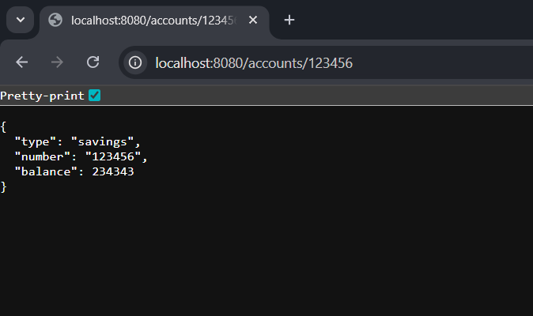

Loan Port 8081:

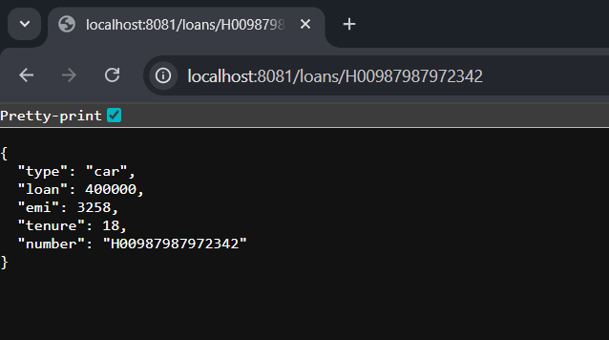

After Combining the two microservices:

